Job History
Subsea Well Tubing and Instrumentation Leak

Operator: Independent Operator
Field: Atwater Valley Area, Gulf of Mexico
Well Data: Subsea Oil and Gas Production well flowing back to Platform in the Gulf of Mexico. Water depth 4400 feet.
Problem (1): Well tubing was getting plugged with Asphaltynes, therefore, the well was on que to have a Deepwater intervention vessel with Coiled Tubing on board to wash down to the Sub Surface Safety Valve. It was also noticed before the intervention, that the tubing was communicating with the production annulus above the SCSSV.

Problem (2): A leak in a poppet on the IWOC’s manifold that is used to test between the upper and lower crown plugs of the Subsea Production Tree was leaking and this prevented the removal of the crown plugs. This was issue was realized “AFTER” the Intervention Vessel , as well as, 3 other service lines were on the payroll.

Solution (1a): “Leaking Poppet”. Once this leak was realized, diagnostics were performed by the Seal-Tite Technician and discussed with Seal Tite Engineering and the Customer. The leak rate was greater than the output of the ROV pump which created uncertainty in the diagnostics. Seal-Tite Engineering decided to utilize a “Triple Stack” of injection cylinders which would allow loading in three sealant types/strengths. This provided the greatest chance of a successful repair in one dive of the ROV.
Once sealant injection began, the first and second cylinders volumes were depleted without success. However once the third (most aggressive) blend contacted the leak site an instant pressure increase to 4000 psi was observed. The pressure was then staged up to the required test pressure of 12,000 psi successfully. This pressure was maintained as the Intervention Vessel tested the riser and Intervention Stack to allow additional sealant curing.

“Triple Stack” of Injection Cylinders
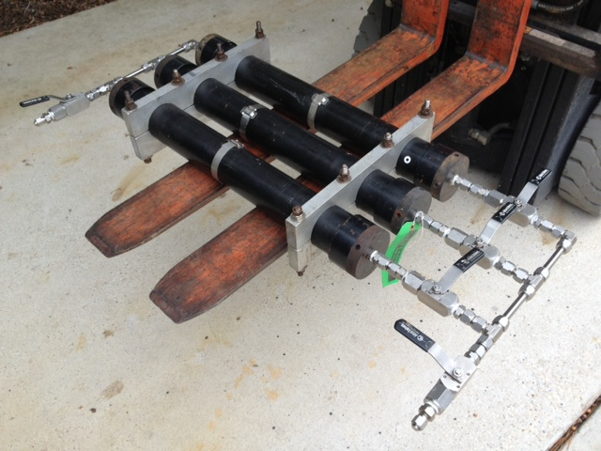
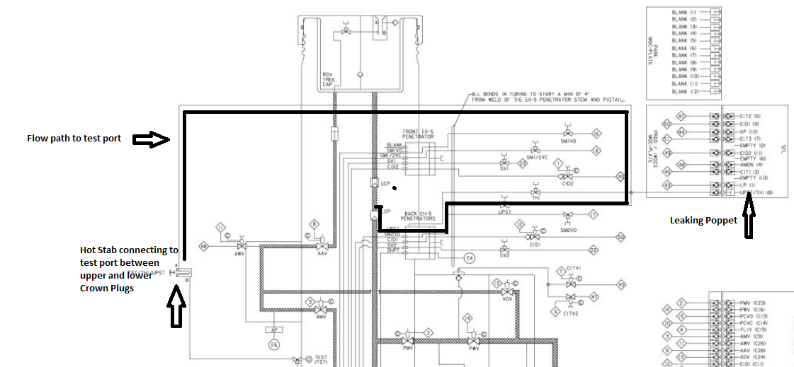
Note* A Large concern of the Customer was the potential of plugging the control lines while attempting to seal the leak eliminating future communication with the port, since the sealants are pressure differentially activated, this was not an issue.
Solution (1b) Once the tubing leak was successfully sealed, the operation of leaving location involved the Crown Plugs to be re-installed and tested. Once again the poppet was tested to 12,000 psi verifying crown plug and poppet integrity.
Solution (2): “Tubing Leak”. Using ARCHER’s LeakPoint® log, the customer was able to locate the leak site in the tubing. Initially it was planned to set a plug below the leak site to serve as a base for sealant spotted across the leak. Due to tubing nipple restrictions above the leak this was considered too risky and coiled tubing was selected for the operation. Approximately 4 bbls of sealant were “bottom loaded” into the coiled tubing to ensure an effective delivery across the leak. The sealant was then spotted in a balanced plug and squeezed into the leak. Using Seal-Tite Engineered Sealants, the leak was repaired to a final test pressure of 10,120 psi.
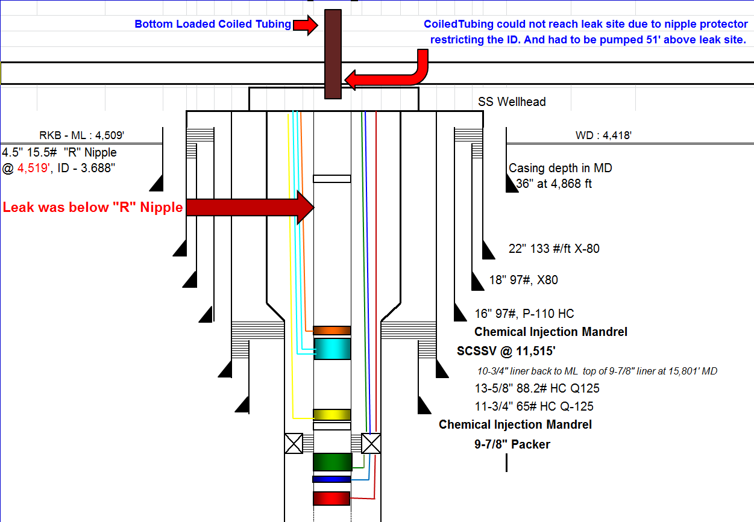

Results: By choosing “ Seal-Tite Internationals Engineered Sealing Solutions” both the “Poppet” and “Tubing” leaks were successfully sealed and tested saving the customer lost production, as well as, costly workover operations and excessive intervention costs due to unforeseen complications and events.

